http://www.bridgechurches.org.uk/?p=5984
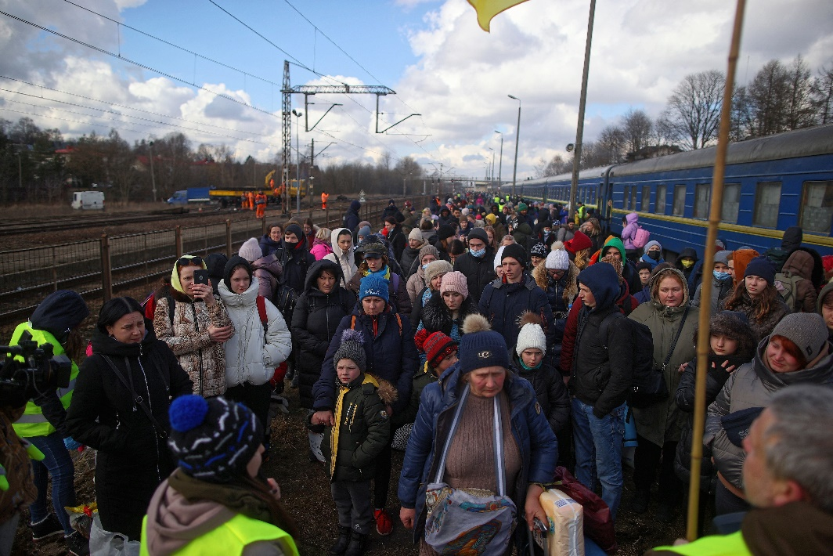
Please Help!
They need food, water, shelter and care.
A Simple Lent Lunch
in Aid of
the People of Ukraine
Place, Time, Date:
Contact:
All monies raised will be sent by the Parishes of the Meon Bridge Benefices to reputable organisations helping
the injured and the refugees.

